Student Assessment Submission and Declaration
When submitting evidence for assessment, each student must sign a declaration confirming that the work is their own.
Student name: ADEL SHURAB  21023153 |  | Assessor name:  Mohammed Eshtay
Issue date (1St Submission):  15/11/2022 | Submission date (1St Submission):  20/12/2022 |  | Submitted on:
In case of resubmission
Issue date (2nd Submission):  24/12/2022 | Submission date (2nd Submission):  28/12/2022 |  | Submitted on:
Programme: Higher National Diploma in computing – Intelligent Systems
Assignment number and title: 1: Fundamentals of Data Analytics

Your Solution HERE
TASK 1 :
Q1: data analytics activities: : (K.Kalyan, 2022)

There are 5 core activities of data analysis:
- Stating and refining the question.
- Exploring the data.
- Building formal statistical models.
- Interpreting the results.
- Communicating the results.

1-Stating and refining the question:
Examples : Descriptive, Exploratory Inferential, Predictive, Causal, Mechanistic.

2-Exploring the data:
examples: Variable identification, Univariate analysis, Bi-variable analysis, Detect and treat missing values, Detect and treat outliers.

3-Builiding formal statistical models:
Regression model, Classification model, K-means clustering, Reinforcement learning, Parametric, Nonparametric, Semiparametric.
4-Interperting the result :
Assembling the information you need.
Developing findings or isolating the most relevant inputs.
Developing conclusions
Coming up with recommendations or actionable solutions.)

5-Communicating the results:
these steps of Communicating the results

What evaluation results should you communicate?
2. Why are you sharing these results?
3. Who needs to know?
4. How should you communicate your evaluation results?
Q2 : List of three tools using data analysis: (Top 10 data analytics tools in 2023: Data Analytics Tools, 2022)

1-EXCEL : is a platform that will enable you to gain more understanding from your data. Microsoft Excel, one of the most widely used tools for data analytics, offers users options like sharing workbooks, working on the most recent version for real-time collaboration, and uploading data directly from a photo to Excel, among others.
2-Tableau: is a market-leading business intelligence solution that is used to easily analyze and present data. becoming a leader in the 2020 Gartner Magic Quadrant You can work with live data sets in Tableau for the eighth year in a row, which gives you more time to focus on data analysis rather than data wrangling.
3-power bi : is a Microsoft business analytics software. It offers dynamic visualizations with self-service business intelligence features, allowing end users to build dashboards and reports on their own without any assistance, and was named a leader in the Gartner 2020 Magic Quadrant for the 13th consecutive year.
Q3: three programming languages using data analysis: (Top 6 data science programming languages 2023 [hand-picked], 2022)

Scala : This sleek, contemporary programming language was developed in 2003, which is a lot more current. In the beginning, Scala was created to solve problems with Java. Web programming and machine learning are just two examples of its applications. For managing massive data, it is also a scalable and efficient language. Scala provides concurrent and synchronized processing in modern organizations together with object-oriented and functional programming.
Python : is a high-level programming language that's open source and popular among technical analysts and data scientists. It now has more global developers than Java and more than 200,000 packages available. Python is capable of handling a wide range of studies on its own, as well as integrating with third-party machine learning and data visualization applications. Matplotlib, Plotly, and Seaborn are three popular data visualization programs. Python can also be used to integrate with other analytics platforms.
R : is a computer language and computing environment that focuses on statistics and graphical data visualization. R has a plethora of graphical tools and over 15,000 open source packages, many of which are useful for importing, manipulating, modeling, and visualizing data. Users without programming abilities should go elsewhere because the environment allows technical analysts with programming skills to build practically any type of data analysis.

Q4: three data analytics methods : (6 types of data analysis that help decision-makers, n.d.)

- Descriptive analytics: What happened?
Any analytical reflection must begin with a descriptive analysis method in order to answer the question, "What happened?" In order to produce useful insights for your organization, it achieves this by organizing, processing, and interpreting raw data from diverse sources.

The ability to deliver our ideas in a meaningful way depends on the descriptive analysis we perform. Although it is important to note that this analysis by itself cannot tell you what will happen in the future or provide an explanation for why something happened, it will organize your data and make it suitable for further research.
- Predictive analytics: What is likely to happen in the future?
With the predictive approach, you may foretell what will happen by looking into the future. It employs machine learning (ML) and artificial intelligence (AI) in addition to the outcomes of the aforementioned descriptive, exploratory, and diagnostic analysis to do this (AI). In this way, you can explore your data to find links, casualties, and future trends as well as potential issues or inefficiencies.

With the aid of predictive analysis, you can plan and create projects that will not only improve your numerous operational processes but also give you a crucial competitive advantage. You can make an educated estimate of how events may play out in specific business areas if you can use data to understand why a trend, pattern, or event occurred.
- Prescriptive analytics: What is the best course of action to take?
One more of the best research-related analysis techniques. Prescriptive data techniques differ from predictive analysis in that they focus on identifying patterns or trends and applying them to create adaptable, useful business strategies.

You will actively participate in the data consumption process by delving into prescriptive analysis and using well-organized sets of visual data as a potent remedy for new problems in a variety of crucial areas, such as marketing, sales, customer experience, HR, fulfillment, finance, logistics analytics, and others.
Q5: Descriptive analytics:
Descriptive analytics is the process of using current and historical data to identify trends and relationships. It’s sometimes called the simplest form of data analysis because it describes trends and relationships but doesn’t dig deeper.
descriptive analytics techniques:
sorting: We use sorting to arrange the names, for example, according to the letter, number, or rank, in order to make it easier for us to find the required faster.
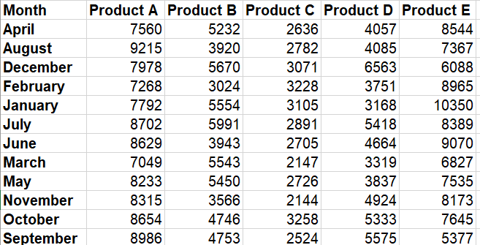
I used sorting by A to Z
Filtering :
We use the filter to filter the groups that we want or even individuals to make it easier to know where when you have thousands of data, this will help me very much.
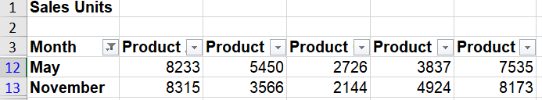
I used filtering to find sales units in May and November
Sum: We use the sum to collect quickly, to make it easier for us and to save us time
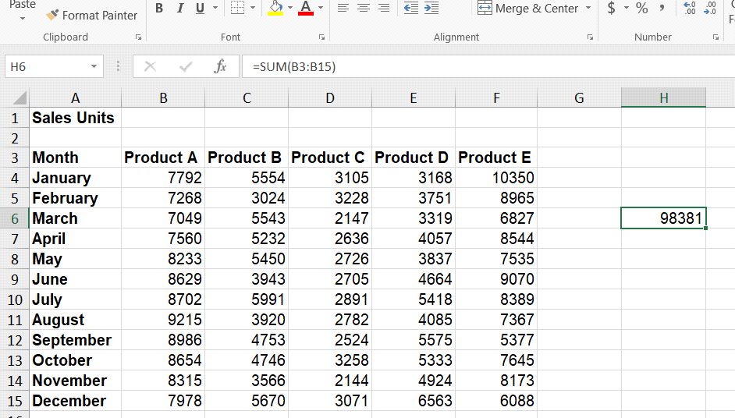
I used sum to sum sales units in product A .
TASK 2:
FORM SHEET :
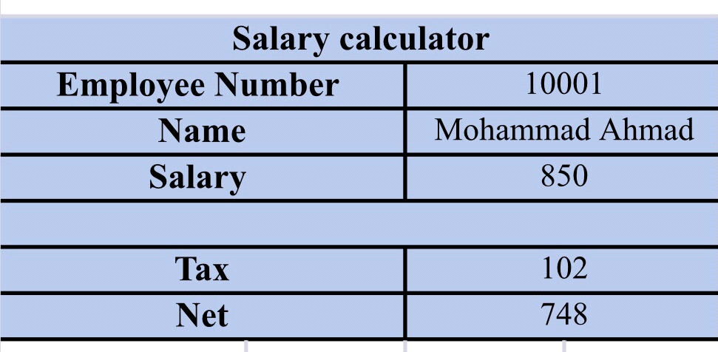
In this table, it is possible to find out the name, salary and tax on the salary and nat by the employee number and the tax is 12% on salaries above 800 and 5% on other salaries
Pareto sheet:
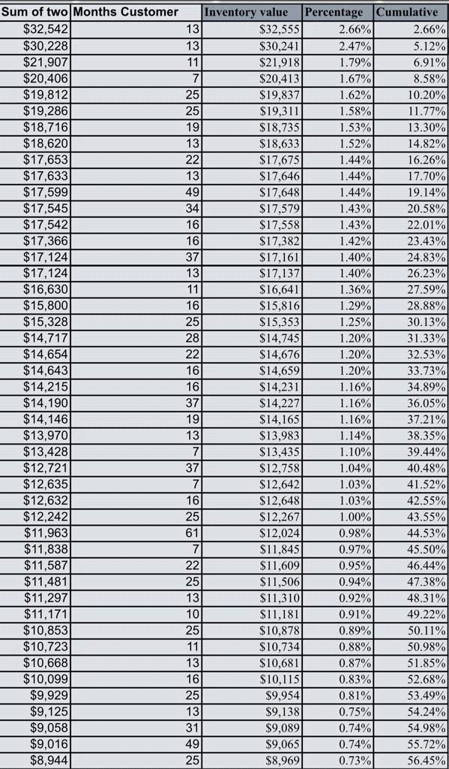

fillter sheet:
Here in this paper I took out the number of employees who have been working for less than 12 months.
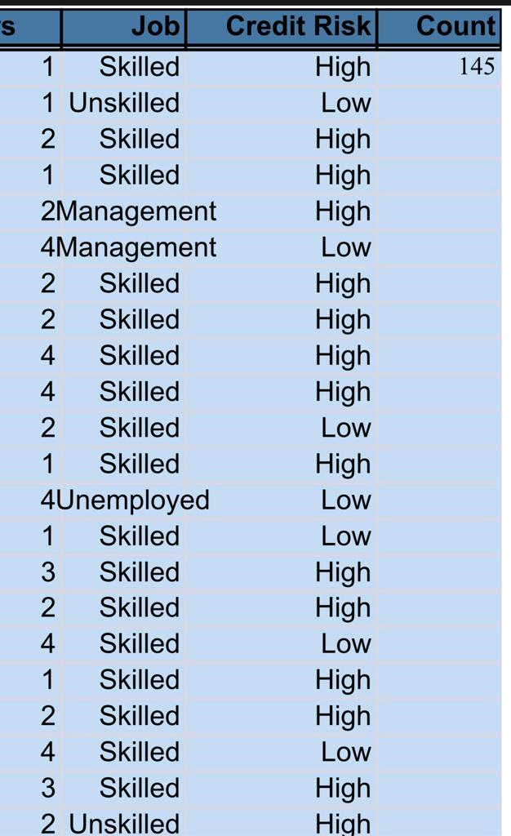

Here, the risks to the credit cards of these employees were extracted.
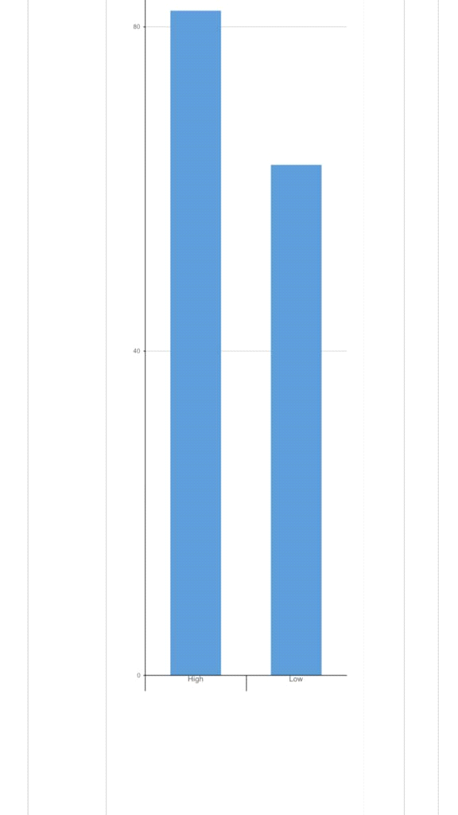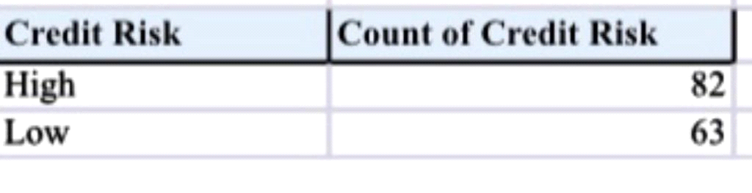￼￼
EMPLOYEE SHEET:

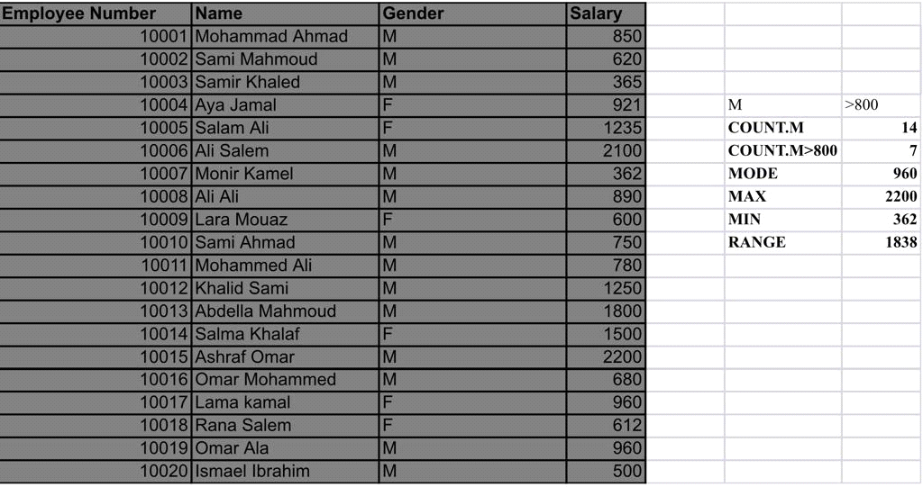
Here in the employees paper I extracted the number of men and extracted the number of men who take a salary above 800 and extracted the average salary between men and women and Find the most frequent salary for males and for females
Who is most consistent :is omar alaa his salary 960 and lama kamal her salary is 960
because The employees consistently provide excellent work. "His words and deeds are entirely consistent." "The company produces a wide range of products consistently." "The outcomes were remarkably consistent."

TASK 3:
BIOILOGY SHEET:
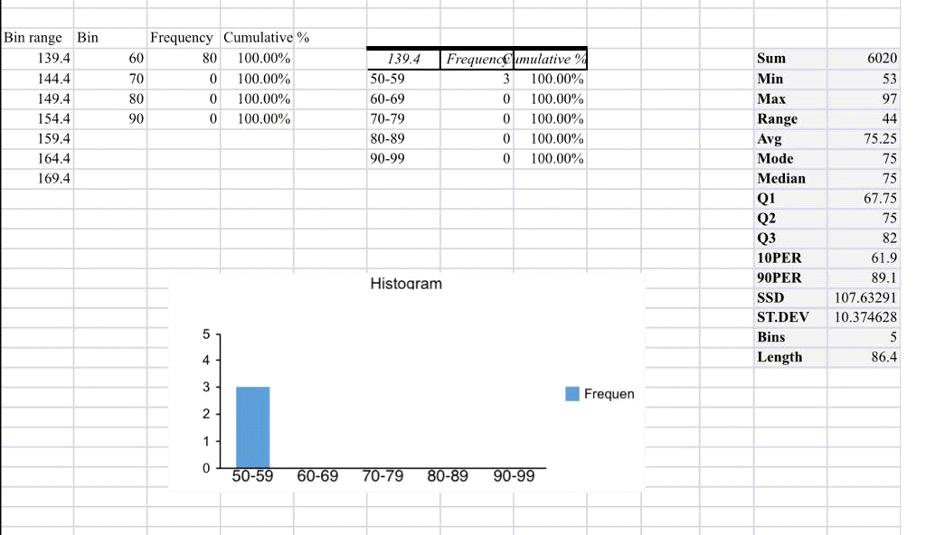
here in biology sheet i Find the sum, the lowest grade, the highest grade, the range, the average, the mode, the median and the sample variance and standard deviation. and i Find the first, 2nd and 3rd quartile, 10th and 90th percentiles. Interpret the results. and i Create a histogram with 5 bins (50-59,60-69,…,90-100).

What can you infer from the chart?
I notice through the graph the recurrence rate, and here the highest recurrence rate is at 50-59.
SALARIES SHEET :
1-
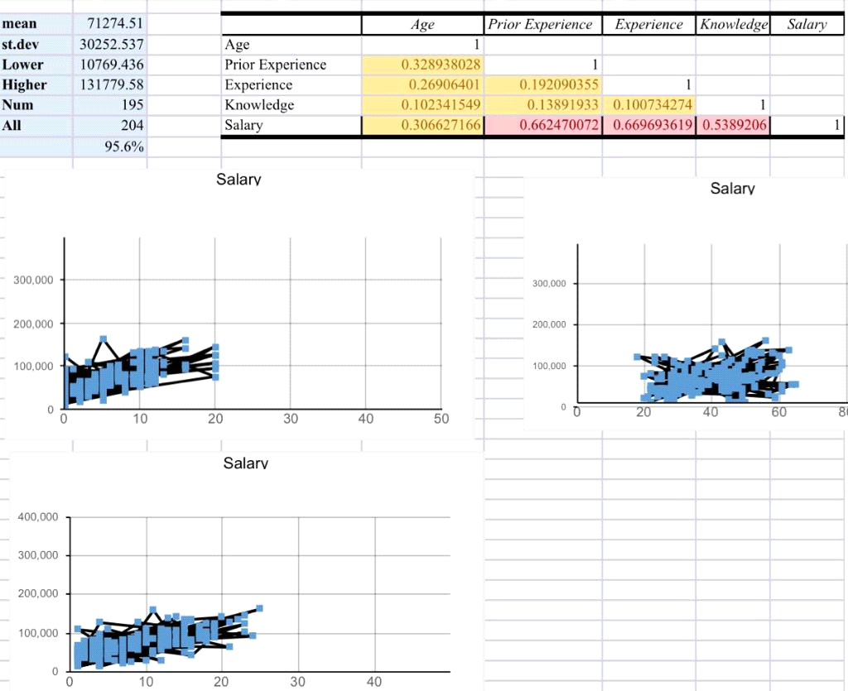
here in salarise sheet i Create a table of correlations between the variables and i Create scatterplots of Salary (Y axis) versus each of Age, Past Experience and Experience.

2-The variable that is strongly related to the annual salary is the variable (experience) because it has the highest percentage as shown in the picture
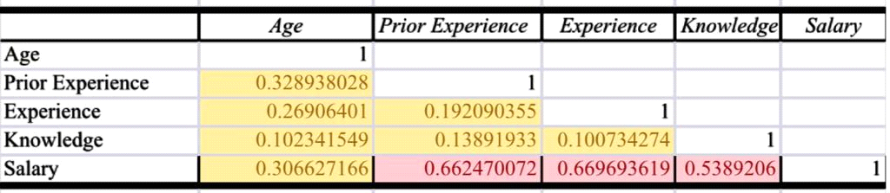

3- outliers :
yes we have one outliers it is 3.061
and outliers mean a data point or set of values that are significantly different from the average or expected range in a statistical sample or division
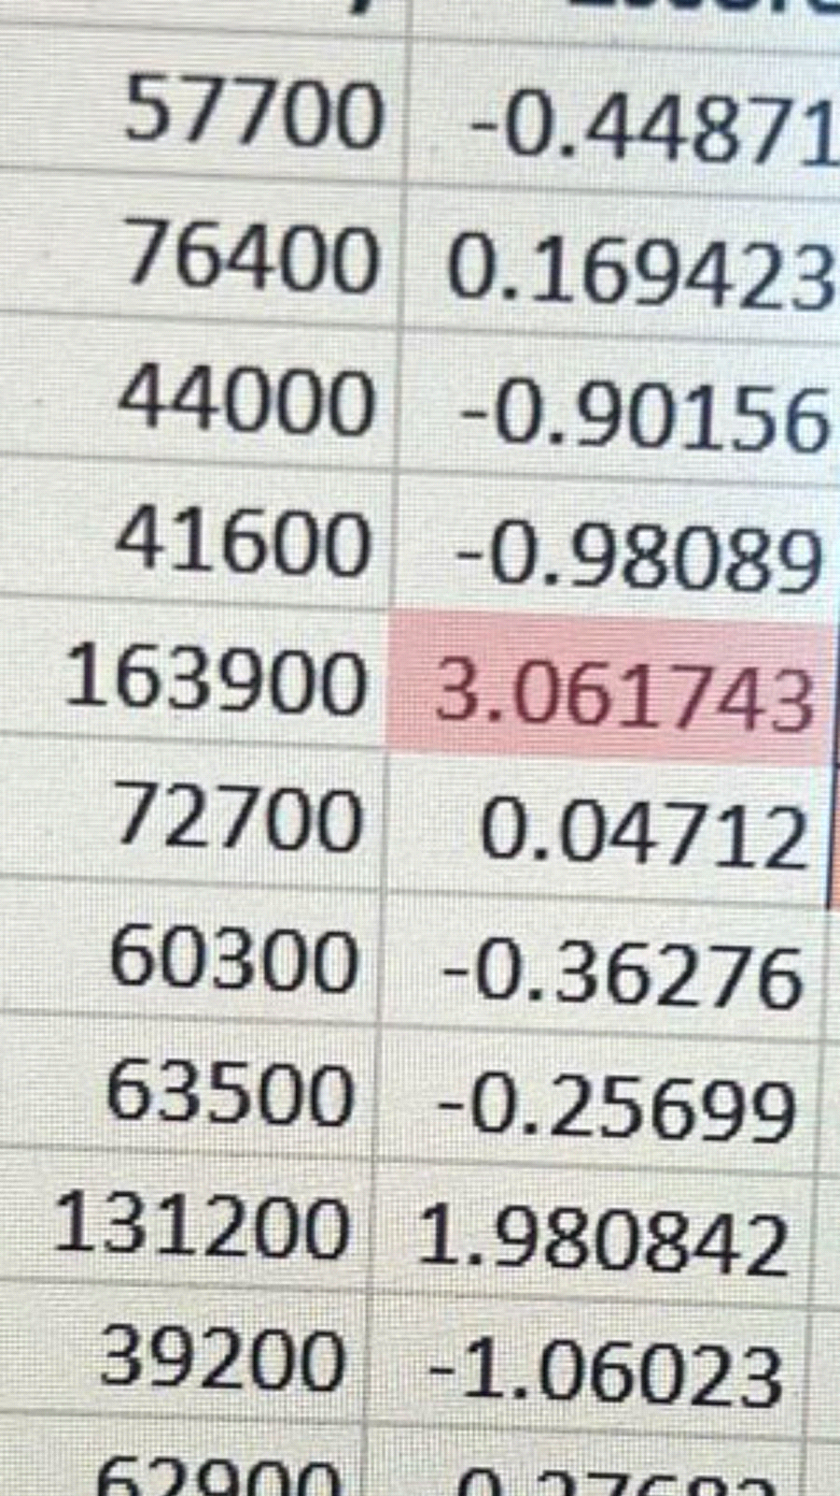
SALES SHEET :
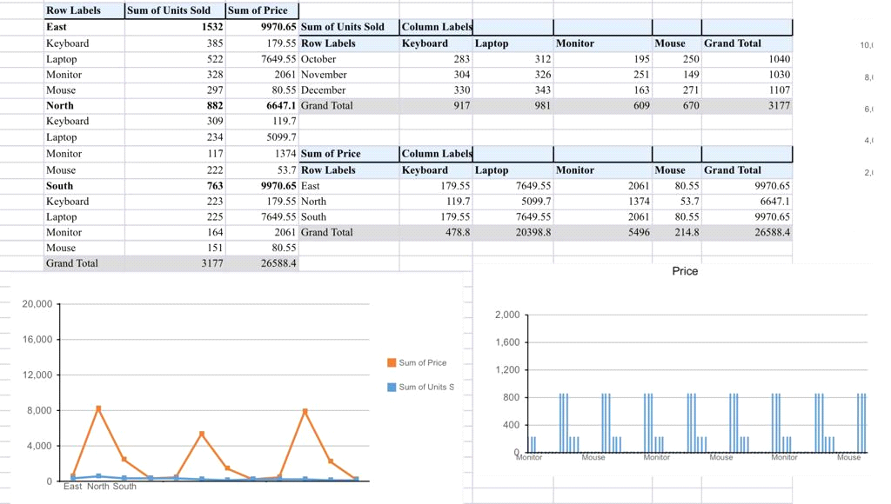

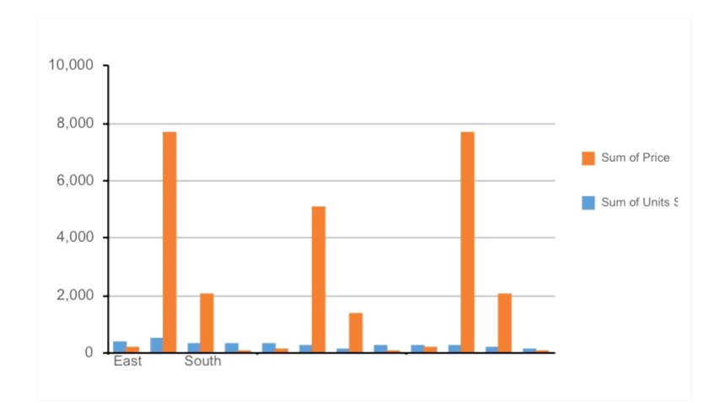
Here in this paper I made a BAVIOT table and a BAVIOT chart to summarize the data for waste reading and added a dashboard to increase interest in the data
3- Dashboard:There is no comparison between the total sales price and the total unit price, and the manager can benefit from it to know the size of the profits easily. As you can notice, the data conversion facilitates the process of understanding what is going on, and thus the ease in decision-making.
To clarify the idea only, the car driver (the manager) in order to be successful must have a lot of information and details about his car (his company), such as its advantages and problems, and how to control its resources and capabilities. However, if he is driving, he needs to know some quick information that enables him to drive (management). It needs speed, engine temperature, and the level of gasoline in the car to be able to make important decisions such as increasing or decreasing speed, refueling or completing the road, and other important readings. That is why the dashboard was designed, as it contains the most important data that helps him in the right driving. And in order to be able to read it quickly, it was designed to give the most important indicators of the car's position while driving in an easy-to-read manner.
Student Beverage:
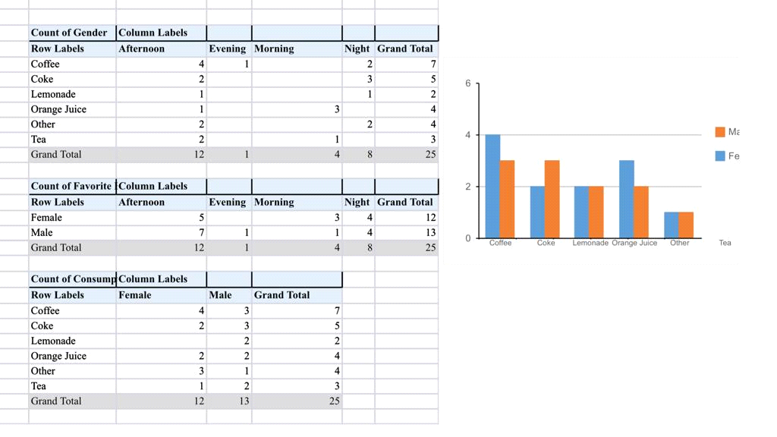
Here in this paper I made a Paviot table for each of the two variables
To clarify the data and make it easier to read, and I also added a graph to facilitate it more
2-how data analytics will help the managers to take the decisions.
data analytics helps managers dynamics of their business, they can analysis their data, control their profits, expect what will happen through data, in another word interpret and monitor emerging risks and build mechanisms for constant feedback and improvement .
And data analysis helps managers in many things, including the filter, sum, and percentage, and this is shown through the Excel file, which specifically the sales sheet used a baviot table, and this helps managers when they have large amounts of data and want to analyze it, so when the manager has a huge database, he will have several questions, so this database will be many data, but it is not explained in the required sense, and even if we simplify the data, it will not be in the required form, but if it is summarized we will benefit than her more These and other questions can be answered by studying the table and analyzing its data, but using pivot tables, we can answer these questions in a few seconds if we take advantage of this function and adapt it to what we want.
The graph or paviot chart is important for managers, as it is difficult to draw by hand, but the paviot chart in excel feature made it easier for them to serve, as it is with the required and clear accuracy. For example, in the sales sheet there is a graph showing sales of each type, how many pieces were sold, when and where they were sold, these methods and others It made it a lot easier for company managers
3-How can Data Analysis Influence Decision Make:
To increase production and efficiency, businesses may make better decisions with the use of data analytics. Making data-driven decisions will mostly contribute to a better customer experience. You can collaborate with your IT department to improve employee and customer interactions by using data analytics to better understand these interactions. IT assists marketing teams in achieving audience outcomes and objectives. In light of client feedback, the corporation allocates its budgets more effectively. They can create the correct messages and deliver them to the right audience at the right time thanks to a thorough grasp of their customers The purpose of data in business decisions is to paint a picture of what a company might actually look like when using data to make decisions. This strategy gets insights that make analytics and data tangible to those without analytics experience and clarifies the company's mission statement. When applied for predictive analysis of sales, equipment depreciation, and asset risk, advanced data technologies through AI and machine learning become understandable to a wider society. Additionally, it raises overall company performance. Data analytics can be used to determine where a person or a department needs to improve.

References
6 types of data analysis that help decision-makers. (n.d.). Retrieved from Velvetech: https://www.velvetech.com/blog/types-of-data-analysis/
K.Kalyan. (2022, november 29). MAKE ME ANALYST. Retrieved from 5 Core Activities of Data Analysis | Epicycles of Data Analysis: https://makemeanalyst.com/5-core-activities-data-analysis-epicycles-data-analysis/
Top 10 data analytics tools in 2023: Data Analytics Tools. (2022, nov 18). Retrieved from Edureka: https://www.edureka.co/blog/top-10-data-analytics-tools/
Top 6 data science programming languages 2023 [hand-picked]. (2022, nov). Retrieved from upGrad blog: https://www.upgrad.com/blog/data-science-programming-languages/

Plagiarism
Plagiarism is a particular form of cheating. Plagiarism must be avoided at all costs and students who break the rules, however innocently, may be penalised. It is your responsibility to ensure that you understand correct referencing practices. As a university level student, you are expected to use appropriate references throughout and keep carefully detailed notes of all your sources of materials for material you have used in your work, including any material downloaded from the Internet. Please consult the relevant unit lecturer or your course tutor if you need any further advice.
Student Declaration
Student declaration
I certify that the assignment submission is entirely my own work and I fully understand the consequences of plagiarism. I understand that making a false declaration is a form of malpractice.

Student signature: ADEL SHURAB Date:19/12/2022

